**Web Designing Assignment**

**Term – 1**

**Module (HTML) - 1**

**Question.1 -> Are the HTML tags and elements the same thing?**

**Ans.** No, HTML tags and elements are not the same.

Tags are the building blocks of HTML. They indicate the start, end of an element and are enclosed in angle brackets [ e.g., <p>,.</p>].

Elements are the components of an HTML document, formed by a start tag, content, and an end tag. For instance, a paragraph element would be

* e.g.,

    <p>This is a paragraph.</p>

---------------------------------------------------------------------------------------------------------------------------

**Question.2 -> What are tags and attributes in HTML?**

**Ans.** In HTML Tags define elements. [ e.g., Heading, Paragraph <p>, .</p>].

In HTML Attributes provide additional information about those elements. [ e.g., Links, Image, Audio, Video].

----------------------------------------------------------------------------------------------------------------------------

**Question.3 -> What are void elements in HTML? With Example.**

**Ans.** Void elements in HTML have no closing tag and cannot contain content.

* Examples:
* <br> (The “br” element represents a line break)
* <img> (An img element represents an image.)
* <input> (The input element represents a typed data field, usually with a form control to allow the user to edit the data.)

----------------------------------------------------------------------------------------------------------------------------

**Question.4 -> What are HTML Entities? With Example.**

**Ans.** An HTML entity is a piece of text ("string") that begins with an ampersand ( & ) and ends with a semicolon ( ; ).

* Examples: 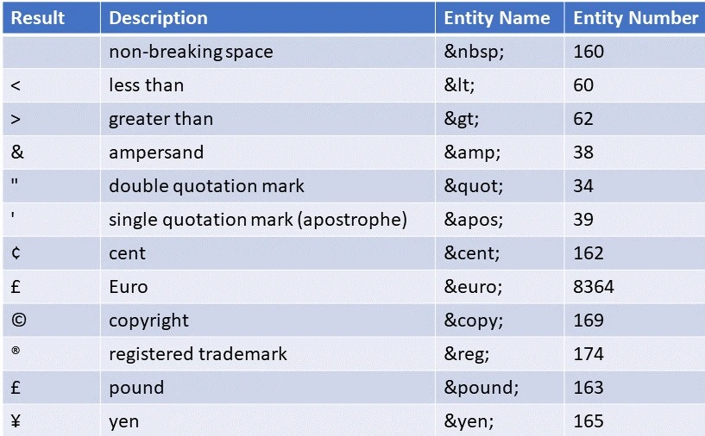

----------------------------------------------------------------------------------------------------------------------------

**Question.5 -> What are different types of lists in HTML? With Example.**

**Ans.** HTML has three types of lists:

* Unordered Lists (<ul>):
* Example:
* **<ul style="list-style-type: disc;">**
* **<li>abc</li>**
* **<li>def</li>**
* **<li>ghi</li>**
* **</ul>**
* Ordered Lists (<ol>):
* Example:
* **<ol type="A" start="105">**
* **<li>abc</li>**
* **<li>def</li>**
* **<li>ghi</li>**
* **</ol>**
* Description Lists (<dl>):
* Example:
* **<dl>**
* **<dt>Chai -></dt>**
* **<dd>Hot Chai</dd>**
* **<dd>Green Tea</dd>**
* **<dt>Coffee -></dt>**
* **<dd>Hot coffee</dd>**
* **<dd>Cold Coffee</dd>**
* **</dl>**

----------------------------------------------------------------------------------------------------------------------------

**Question.6 ->**  **What is the ‘class’ attribute in HTML? With Example.**

**Ans.** The class attribute in HTML is a global attribute that assigns one or more names to an element. It's mainly used for styling purposes with CSS or manipulating elements with JavaScript.

Example:

**<title>Document</title>**

**</head>**

**<style>**

**.main{  }**

**</style>**

**<body>**

**<div class="main"></div>**

**</body>**

----------------------------------------------------------------------------------------------------------------------------

**Question.7 ->**  **What is the difference between the ‘id’ attribute and the ‘class’ attribute of HTML elements? With Example.**

**Ans.**

**“id” :-**

Unique identifier for a single element. Used for specific styling/scripting

Also known mark as “.”

**“Class” :-**

Label for multiple elements. Used for grouping and styling.

Also known mark as “#”

* Example:

**<title>Document</title>**

**<style>**

**.note {**

**color: blue;**

**font-style: italic;**

**}**

**#main-title {**

**color: red;**

**text-align: center;**

**}**

**</style>**

**</head>**

**<body>**

**<p class="note">This is a note.</p>**

**<p class="note">Another note here.</p>**

**<h1 id="main-title">Welcome to My Website</h1>**

**</body>**

----------------------------------------------------------------------------------------------------------------------------

**Question.8 ->**  **What are the various formatting tags in HTML?**

**Ans.** The various formatting elements include the b, i, u, strong, em, s, sub, and sup tags.  
These tags can be used to change the font style, size, color, and other visual properties of the text.

----------------------------------------------------------------------------------------------------------------------------

**Question.9 ->**  **How is Cell Padding different from Cell Spacing? With Example.**

**Ans.**

**Cell Padding:-**

Space between cell content and border.

**Cell Spacing:**-

Space between cells.

* **Example:**

**<table border="2" cellspacing="15px" cellpadding="30px">**

**<tr>**

**<td>a</td>**

**</tr>**

**</table>**

----------------------------------------------------------------------------------------------------------------------------

**Question.10 ->**  **How can we club two or more rows or columns into a single row or column in an HTML table? With Example.**

**Ans.** In HTML tables, use colspan to merge columns & rowspan to merge rows.

* **Example:**

**<body>**

**<table border="2" cellpadding="30px">**

**<tr align="center">**

**<td rowspan="2">A</td>**

**<td>B</td>**

**<td>C</td>**

**</tr>**

**<tr align="center">**

**<td>O</td>**

**<td>B</td>**

**<td colspan="2">C</td>**

**</tr>**

----------------------------------------------------------------------------------------------------------------------------

**Question.11 ->**  **What is the difference between a block-level element and an inline element?**

**Ans.**

**Block-level element:-**

Block-level elements start on a new line and take up the full available width, They are used for structuring content and layout.

**inline element :-**

inline elements flow within the text and only take up necessary space. They are used for styling and formatting small sections of text.

----------------------------------------------------------------------------------------------------------------------------

**Question.12 ->**  **How to create a Hyperlink in HTML? With Example.**

**Ans.** In HTML, use the <a> tag to create hyperlinks. The href attribute specifies the link's destination.

* **Example:**

**<a href="https://maps.app.goo.gl/U4mvh5SDieGDQ8tm9">Click to get Location</a>**

*This creates a link displaying "Visit Example Website", which takes the user to "https://maps.app.goo.gl/U4mvh5SDieGDQ8tm9" when clicked.*

----------------------------------------------------------------------------------------------------------------------------

**Question.13 ->**  **What is the use of an iframe tag? With Example.**

**Ans.** An iframe tag embeds another webpage within the current webpage.

* **Example:**

<iframe src="https://www.example.com"></iframe>

*This will display the content of https://www.example.com within the current page.*

----------------------------------------------------------------------------------------------------------------------------

**Question.14 ->**  **What is the use of a span tag? Explain with example?**

**Ans.** The uses of a span tag include changing the style or color of a part of the text, highlighting a section of text, and inserting icons or small graphics inline with text.

* **Example:**

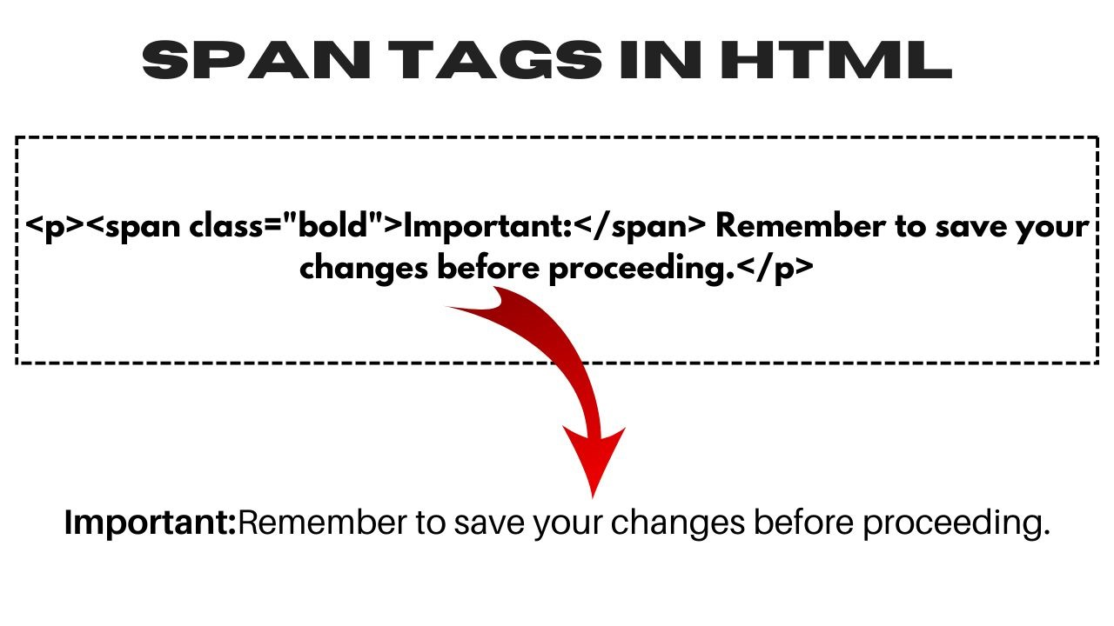

----------------------------------------------------------------------------------------------------------------------------

**Question.15 ->**  **How to insert a picture into a background image of a web page? With Example.**

**Ans.** You can't directly insert a picture into a background image, but you can overlay them using CSS.

* **Example:**

<title>Document</title>

</head>

     <style>

        .main{

            background-image: url(pexels-photo-1402787.jpeg);

            height: 900px;

            width: 1450px;

            border: 5px solid royalblue;

            background-repeat: no-repeat;

            /* background-size: cover; */

            background-size: contain;

            background-position: center;

        }

     </style>

<body>

    <div class="main"></div>

    <!-- <img src="C:\Users\91968\Desktop\html\CH2. CSS\Nature.jpg" alt=""> -->

</body>

----------------------------------------------------------------------------------------------------------------------------

**Question.16 ->**  **How are active links different from normal links?**

**Ans.**

**Active link :-**

Active links are temporarily highlighted (usually red) when clicked or hovered over, indicating the browser is processing the link and underlined.

**Normal link :-**

Normal links are unclicked links, typically Orange and In simple text.

----------------------------------------------------------------------------------------------------------------------------

**Question.17 -> What are the different tags to separate sections of text?**

**Ans.** There are some tags to separate section of text:

* Example:

<p> for paragraphs

<br> for line breaks

<div> for block-level containers

----------------------------------------------------------------------------------------------------------------------------

**Question.18 ->**  **What is SVG?**

**Ans.** SVG stands for Scalable Vector Graphics, and it's an XML-based markup language that's used to describe two-dimensional vector graphics. SVG graphics can be directly embedded into HTML pages and are supported by all major browsers.

----------------------------------------------------------------------------------------------------------------------------

**Question.19 ->**  **What is difference between HTML and XHTML?**

**Ans.**

**HTML :-**

HTML is flexible, forgiving, and widely used.

**XHTML :-**

XHTML is a stricter version based on XML, requiring well-formed code. but XHTML is less common due to its stricter rules.

XHTML is a stricter, XML-based version of HTML.

|  |  |  |
| --- | --- | --- |
| **Feature** | **HTML** | **XHTML** |
| **Case Sensitivity** | No | Yes |
| **Closing Tags** | Not always required | Required |
| **Syntax** | More lenient | Stricter |
| **Doctype Declaration** | Required | Required |

**\*** Both are used to create web pages*

----------------------------------------------------------------------------------------------------------------------------

**Question.20 ->**  **What are logical and physical tags in HTML?**

**Ans.** In HTML, there's no strict classification of "logical" and "physical" tags. However, the terms are used to describe the general purpose of tags:

**Logical tags :-**

Logical tags describe the meaning or purpose of content.

* **Example :-**

<h1> for a heading, <p> for a paragraph

Physical tags :-

Physical tags directly control the appearance of content.

* **Example :-**

<b> for bold text, <i> for italic text

*Modern HTML encourages using logical tags with CSS for styling, as it provides more flexibility and better accessibility.*

----------------------------------------------------------------------------------------------------------------------------